## Rotating Objects

Frequently it will be necessary to rotate an item on a plan. There are three methods of rotation:

* Free rotate with the rotation handle.
* Right clicking an object/tool and select **Transform** > **Rotate clockwise**, **Rotate counter-clockwise**, **Rotate upside down** or custom **Rotate by degrees** options.
* On selected object, right click on Rotation Handles (curved arrows) on corners.
* Hit **CTRL + R** when an object is selected and it will rotate in 90 degrees increments.
* Micro rotate clockwise with **CTRL + ALT + R** or counter-clockwise with **CTRL + ALT + E**.
* 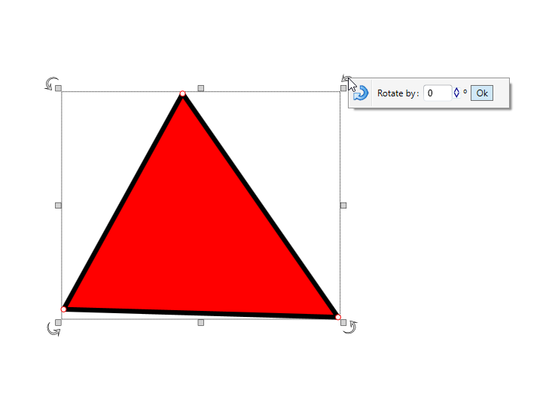
* Rotate_selected_object
* **Note:** You can rotate one or more selected objects at the time.